

CONCEPT NAME



TEAM MEMBERS

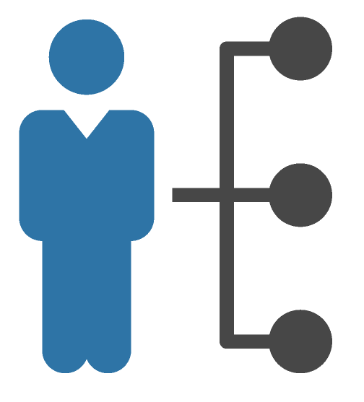

DESCRIBE HOW THE CONCEPT WORKS

WHOM DO WE NEED TO SUCCEED?

NON-PROFIT

PRIVATE   
SECTOR

PUBLIC  
SECTOR

OTHERS



KEY RESOURCE NEEDS

WHAT KEY SHIFT WILL THE CONCEPT

CONTRIBUTE TO?

CURRENT STATE

FUTURE STATE

KEY METRICS:   
HOW WILL WE MEASURE SUCCESS?

ALTERNATIVES (BETTER, EASIER, FASTER)

FIRST STEPS  
(DATE AND TASK)

BIGGEST CHALLENGES AND HOW TO ADDRESS